CASTING OFF THE SHROUD
Lucian

Catalogue of Works

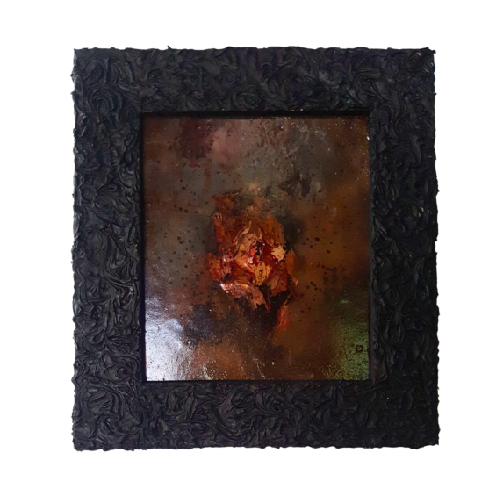 | Matapos ang Limang Libong Dalangin (1)  Lucian  Php 8,000
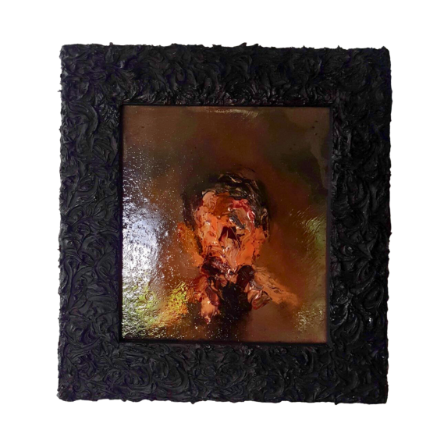 | Matapos ang Limang Libong Dalangin (2)  Lucian  Php 8,000
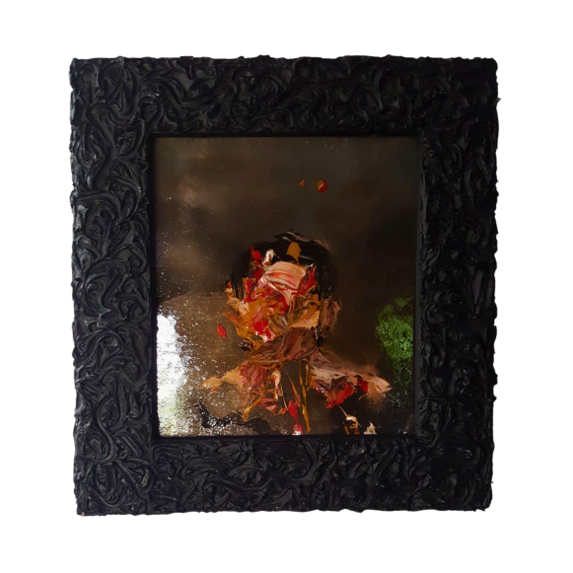 | Matapos ang Limang Libong Dalangin (3)  Lucian  Php 8,000
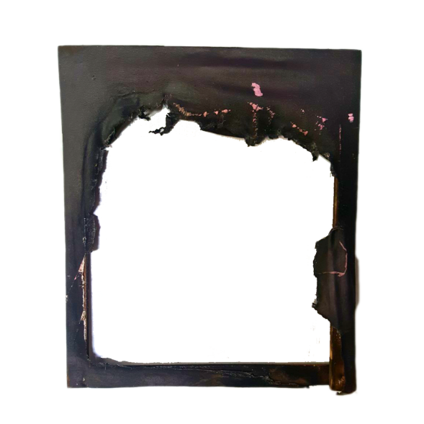 | Nauubos na Ako (1)  Lucian  Php 50,000
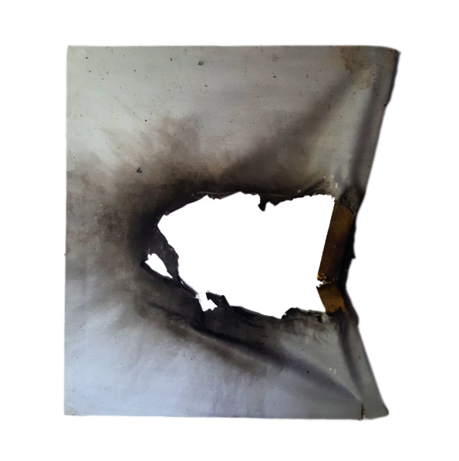 | Nauubos na Ako (2)  Lucian  Php 50,000
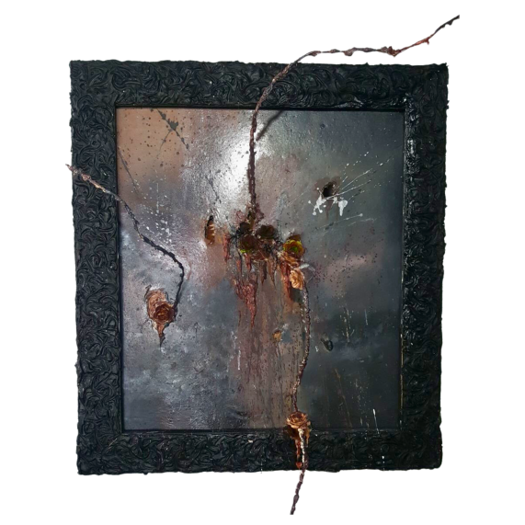 | Under Pressure  Lucian  Php 12,000
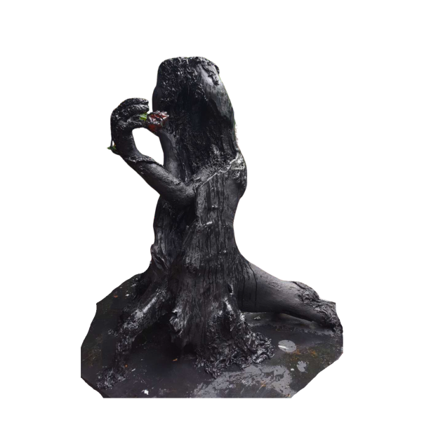 | Hiwaga ng Nakaraan  Lucian  Php 35,000
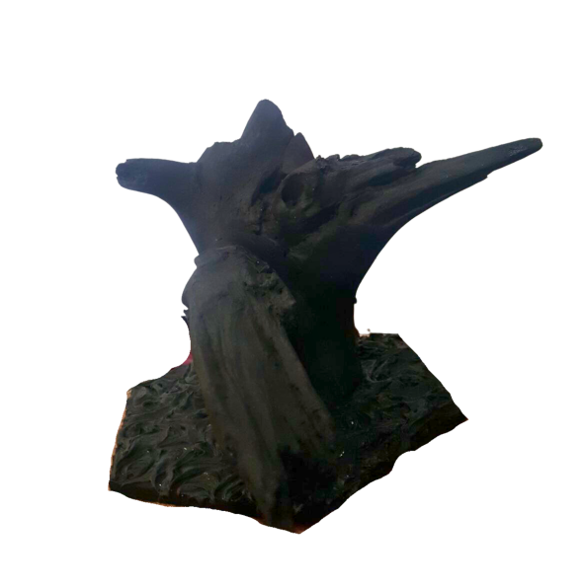 | Aftermath (1)  Lucian  Php 12,000
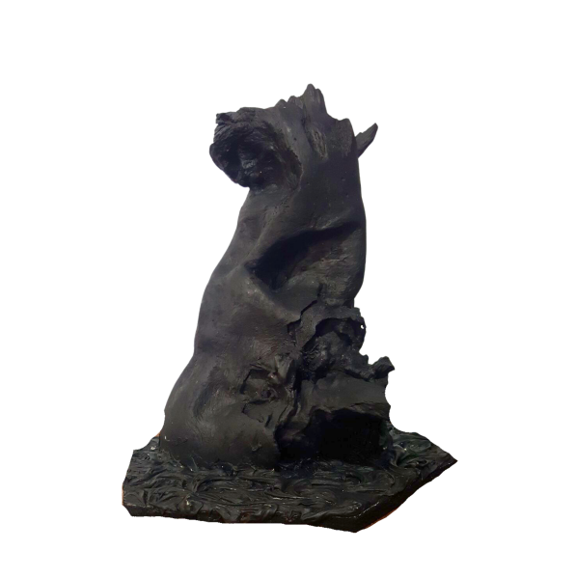 | Aftermath (2)  Lucian  Php 12,000
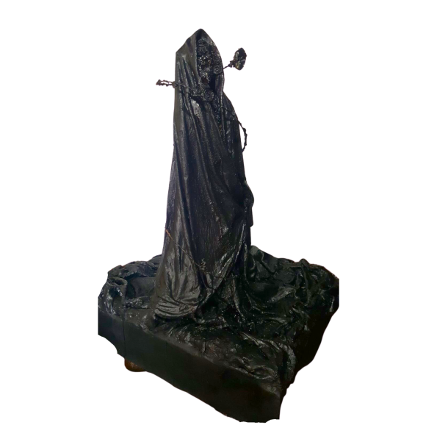 | Casting Off the Shroud  Lucian  Php 25,000

